**Assisted Practice: 3.10 Initialize a Volume Restored from a Snapshot on Linux**

**Step 3.10.1:** Selecting the snapshot

* Go to EC2 dashboard in EBS and click on *Snapshot*

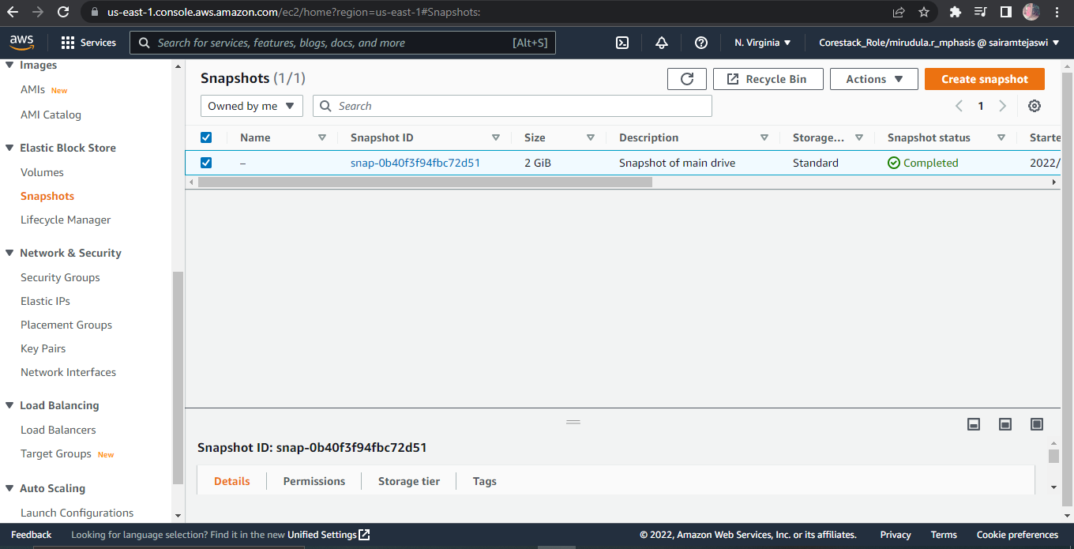

**Step 3.10.2:** Restoring volume from the snapshot

* Select the snapshot and click on *Action*
* *Create Volume*

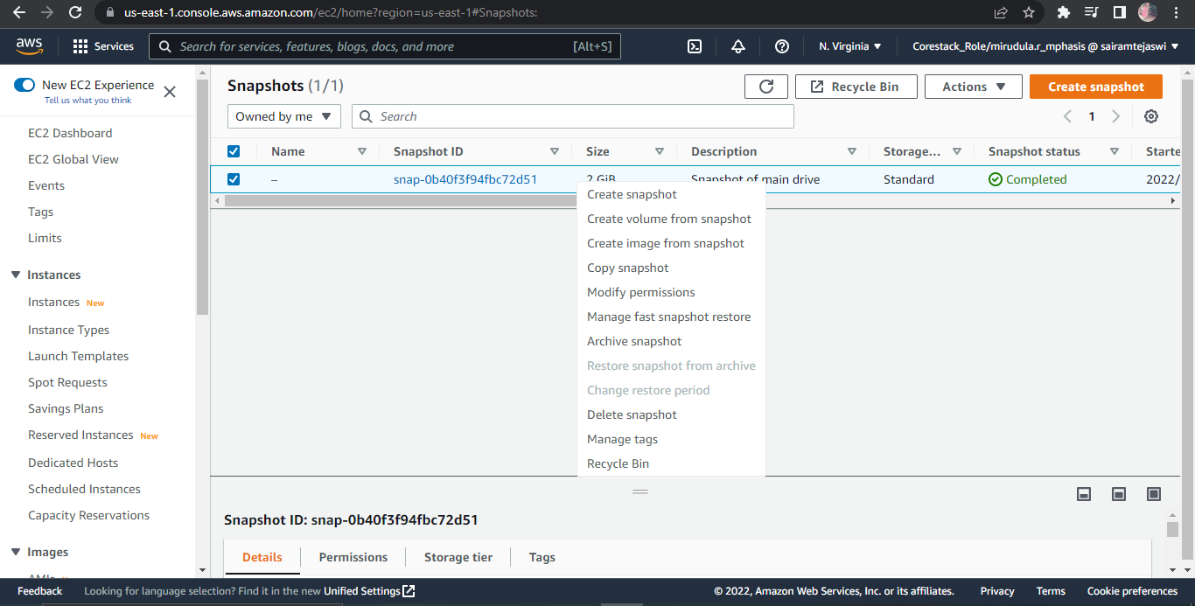

* You can specify the key and value to identify the volume

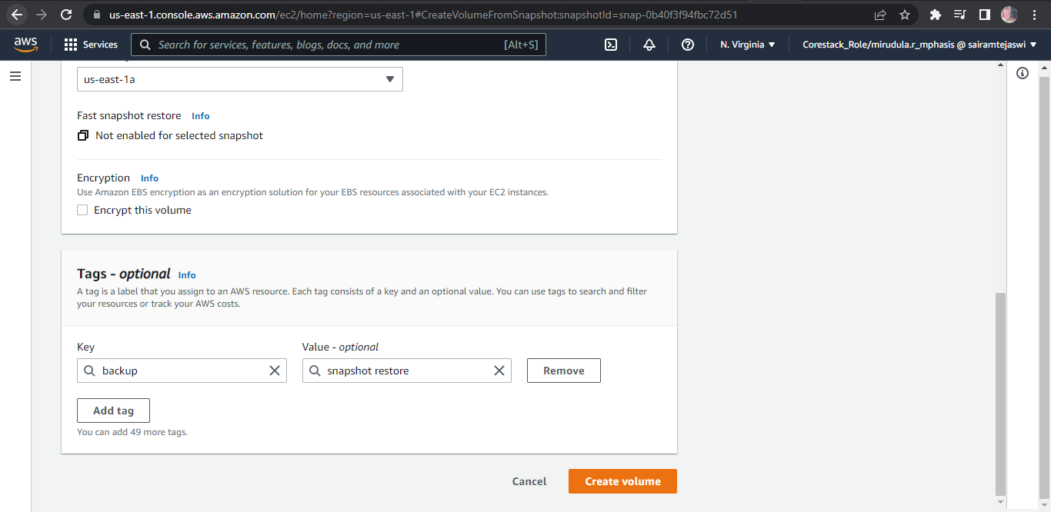

* Restore the volume from the snapshot

